**JAVA FUNDAMENTALS SECTION-4:**

BANAGANAPALLI MUNNA

192372028

**Step 1: List of Products**

**Here are six products that could be stored in the inventory system:**

1. **HP Laptop**
2. **Office Chair**
3. **LED Monitor**
4. **Wireless Mouse**
5. **Mechanical Keyboard**
6. **Desk Lamp**

**Step 2: Product Attributes Table**

|  |  |  |
| --- | --- | --- |
| **Attribute** | **Sample Data** | **Data Type** |
| **Name of the product** | **HP Laptop** | **String** |
| **Price** | **799.99** | **Double** |
| **Number of units in stock** | **15** | **Int** |
| **Item number** | **1001** | **Int** |

**Step 3: Create a Project ‘inventory’.**

**Step 4:Create the Product Class**

**JAVA**

**public class Inventory {**

**// Product class**

**public static class Product {**

**// Instance field declarations**

**private int itemNumber;**

**private String name;**

**private int unitsInStock;**

**private double price;**

**// Default constructor**

**public Product() {**

**// Initializing fields to default values**

**this.itemNumber = 0;**

**this.name = "";**

**this.unitsInStock = 0;**

**this.price = 0.0;**

**}**

**// Parameterized constructor**

**public Product(int number, String name, int qty, double price) {**

**this.itemNumber = number;**

**this.name = name;**

**this.unitsInStock = qty;**

**this.price = price;**

**}**

**// Getter and Setter methods**

**public int getItemNumber() {**

**return itemNumber;**

**}**

**public void setItemNumber(int itemNumber) {**

**this.itemNumber = itemNumber;**

**}**

**public String getName() {**

**return name;**

**}**

**public void setName(String name) {**

**this.name = name;**

**}**

**public int getUnitsInStock() {**

**return unitsInStock;**

**}**

**public void setUnitsInStock(int unitsInStock) {**

**this.unitsInStock = unitsInStock;**

**}**

**public double getPrice() {**

**return price;**

**}**

**public void setPrice(double price) {**

**this.price = price;**

**}**

**// Override toString method**

**@Override**

**public String toString() {**

**return "Item Number: " + itemNumber + "\nName: " + name + "\nQuantity in stock: " + unitsInStock + "\nPrice: " + price;**

**}**

**}**

**// ProductTester class**

**public static void main(String[] args) {**

**// Creating and initializing six Product objects**

**Product product1 = new Product();**

**Product product2 = new Product();**

**Product product3 = new Product(1003, "LED Monitor", 25, 149.99);**

**Product product4 = new Product(1004, "Wireless Mouse", 50, 29.99);**

**Product product5 = new Product(1005, "Mechanical Keyboard", 40, 99.99);**

**Product product6 = new Product(1006, "Desk Lamp", 20, 49.99);**

**// Displaying the details of each product to the console**

**System.out.println(product1);**

**System.out.println(product2);**

**System.out.println(product3);**

**System.out.println(product4);**

**System.out.println(product5);**

**System.out.println(product6);**

**}**

**}**

**OUTPUT:**

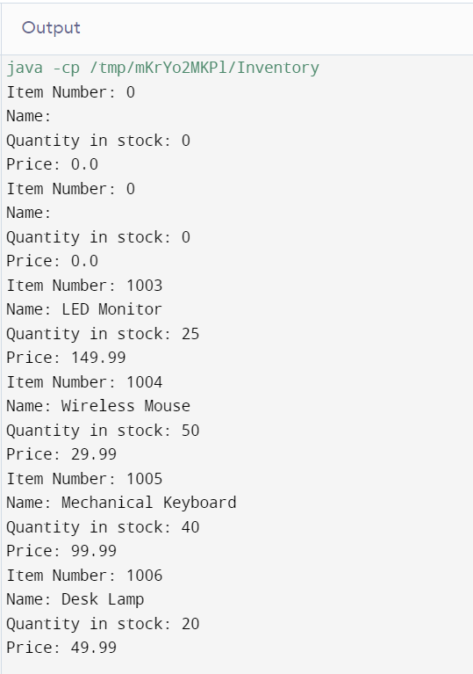

### Save the Project

**Ensure that both Product.java and ProductTester.java are saved in the same directory or within the appropriate package structure if using an IDE like Eclipse or IntelliJ IDEA.**

### Final Notes

**This code creates an inventory system with six products, displaying their details in the console. Make sure to compile and run the ProductTester class to verify everything works as expected.**